Montgomery County Ohio College Promise
Volunteer Mentor Handbook

Table of Contents
Section | Pages
About Montgomery County Ohio College Promise | 1
Scholarship | 2-3
Mentor Selection and Commitment | 4
Background Checks | 5
Mentor Conduct | 6
Policies | 7-8
School Liaisons | 9
Contact | 10
Appendices | 11-13
Signature Page

About Montgomery County Ohio College Promise
About Us
Montgomery County Ohio College Promise (“College Promise”) was founded in 2010 with the goal of providing a life-changing opportunity for 500 students within the community over a 10-year period. These students, whose lives have been impacted by poverty, are identified and selected during their eighth-grade year. Each student is supported during high school by a caring adult mentor who meets with them on a weekly basis at their high school, and may provide additional support beyond that, and through programming offered by the College Promise program.
The selected students, upon the successful completion of high school and meeting the entrance requirements of the partner college or university, are awarded scholarships that allow them to attend college at little or no cost to them or their families. Partner colleges and universities include: Central State University, Denison University, Kettering College, Miami University, Miami University Regionals, Ohio Northern University, Sinclair Community College, the University of Dayton, Wittenberg University, Wright State University, and Xavier University.
Mission
College Promise’s mission is to identify, select and support 500 Montgomery County, poverty impacted, eighth grade students over 10 years who have shown academic promise so that the dream of attending and graduating from college becomes a reality.
Student Commitment
College Promise Scholars sign a contract that pledges they will be alcohol, tobacco, and drug free; be crime free; practice good citizenship; maintain a strong record of school attendance; achieve the required grade point average; participate in school, community, or faith-based activities; and attend weekly meetings with their mentor.
Mentoring
A mentor is a caring adult who freely gives their own time to a young person. A mentor can have a profound effect on the amount of success that a young person might attain. To a young person, a mentor guarantees that there is someone who cares and that they are not alone in dealing with the everyday challenges they face.
Impact
By breaking the cycle of poverty for 500 Montgomery County students, the College Promise program has a profound impact on not only their quality of life but also the greater community. By attaining their college education at a regional college or university, College Promise Scholars will be attractive to Montgomery County employers, which will retain our investment at home.

Scholarship
Who Can Apply
Students eligible to participate in the College Promise program must demonstrate financial need, be currently enrolled as an eighth grader in Montgomery County, and plan to attend a participating Montgomery County high school.

Students selected have attended school regularly, have earned satisfactory grades, are involved in activities, and are committed to doing their best.
Participating High Schools
Archbishop Alter High School | Meadowdale High School
Belmont High School | Miamisburg High School
Brookville High School | Northmont High School
Butler High School | Northridge High School
Carroll High School | Oakwood High School
Centerville High School | Ponitz Career Technology Center
Chaminade-Julienne High School | Spring Valley Academy
Dayton Business Technology High School | Stebbins High School
Dayton Christian High School | Stivers School for the Arts
Dayton Early College Academy | Thurgood Marshall STEM High School
Dixie High School | Trotwood-Madison High School
Dunbar Early College High School | Valley View High School
Jefferson High School | Wayne High School
Kettering Fairmont High School | West Carrollton High School

Qualifications
1. Income eligibility as determined by the United States Department of Agriculture Food and Nutrition Service for Free and Reduced Lunch
2. Demonstrate academic promise, as determined by grades, state test scores, attendance, involvement, recommendations, and additional information submitted.
Student Commitment
- Not to use alcohol, tobacco, or drugs
- Not to engage in criminal conduct or other serious misconduct
- To practice Good Citizenship
- To maintain a strong record of school attendance
- To participate in school co-curricular or extracurricular activities and /or community/faith based activities
- To attend weekly meetings with your assigned mentor
- To attend at-large programs or activities sponsored by College Promise
- To attain a High School Diploma with a Grade Point Average (GPA) and test scores high enough to meet the entrance requirements of partner colleges and universities
Parent/Guardian Commitment
- To provide a supportive environment at home that will contribute to the success of the mentee
- To develop a positive relationship with the high school, mentor, and College Promise staff
- To attend school related functions including but not limited to open houses, scheduling conferences, and parent/teacher conferences
- To attend any at-large programs or activities sponsored by College Promise
- To provide releases necessary to allow College Promise to receive both academic and disciplinary information for the mentee
Application
Completed applications will be accepted September 15-November 15. The application includes:
- Student Information
- Parent/Guardian Information
- Family Income Information
- 2 Letters of Recommendation (at least 1 from a teacher)

Mentor Selection and Commitment
Mentoring
Nothing is more rewarding than making a difference in the life of a young person. A mentor is a caring adult who freely gives their own time to a young person. A mentor can have a profound effect on the amount of success a young person might attain. To a young person, a mentor guarantees that there is someone who cares and that they are not alone in dealing with the everyday challenges they face.
College Promise mentors commit to meeting with their mentee for 30-50 minutes a week at the mentee’s high school and may provide additional support beyond that. Mentors serve as a role model, provide a sounding board, an opportunity to talk and be heard, support, encouragement, guidance, and friendship.
Applying to Become a Mentor
Mentors commit to meeting with their mentees for at least 30-50 minutes a week during the school year for all four years of high school. They agree to give their time and energy to this process in order to make a positive difference in the life of a young person.
Mentors are chosen and retained at the discretion of College Promise. To become a mentor, download, complete, and submit an application or apply online. Mentors must pass a background check and take part in a training session prior to their first meeting with their mentee.
Mentor Commitment
Mentors meet with their mentee on a weekly basis during the school year and are provided contact information for their School Liaison and an academic calendar. Along with these resources, College Promise representatives are available to meet with the mentor, mentee, school official and/or parent or guardian to discuss specific matters.
From time to time, mentors may also meet with their mentees outside of their weekly school meeting setting. Any such out-of-school meeting must be done with the permission of the mentee’s parent/guardian and conducted by the mentor in a manner consistent with all College Promise policies and procedures.
An annual Mentor Roundtable is held during the summertime, which serves as an opportunity for mentors to connect with each other and to receive program updates. Mentors commit to attending all required training sessions and following all College Promise policies and procedures.

Background Checks
All persons must pass, to the satisfaction of College Promise in its sole discretion, a formal background check prior to being accepted as a College Promise mentor and must pass periodic supplemental background checks to ensure their continued fitness to remain in the role of mentor. Background checks will be done through the Mentoring Collaborative or other provider as determined by College Promise.
Organization Location:
The Mentoring Collaborative
1133 S. Edwin C. Moses Blvd., Suite 189
Dayton, OH 45417

Contact:
(937) 512-3179
Times for Prints:
Tuesday-Thursday
9:00 a.m.-11:30 a.m.
1:30 p.m.-4:00 p.m.
Person should bring with them:
- Request for a Background Check via Electronic Fingerprinting (see Appendix A)
- Driver’s License or State ID
Notes:
- Depending upon the person’s prints, the process should take 5-10 minutes
- If you have not lived in Ohio for the last five (5) years, an FBI background check is required. College Promise, however, reserves the right to conduct FBI background checks on all applicants.

Mentor Conduct
As College Promise volunteers, mentors agree and adhere to the following standards of conduct:
A Mentor Shall:
- Always act in a manner that is in the best interest of their mentee
- Be reliable and maintain a regular schedule, committing to the agreed upon times for the weekly school visits with their mentee
- Faithfully notify the School Liaison and the College Promise office of cancellations and schedule changes
- Work independently in the designated school area allowing other school personnel to carry out their responsibilities without interruption
- Meet with their mentee in an area where school staff can freely observe them
- Follow district policies for school visitors, including facility use, attire, and behavior
- Meet with their mentee off school property only with the permission of their mentee’s parent/guardian and consistent with all College Promise policies and procedures
- For any meetings off school property, only meet with their mentee in public places and/or while driving to that location
- Only transport their mentee or mentee’s family members with written permission of their mentee’s parent/guardian and in complete compliance with the College Promise Transportation Policy
- Be culturally aware and respect the cultural differences between their mentee and themselves
- Demonstrate respect, empathy, genuineness, and warmth when working with their mentee
- Maintain confidentiality
- Attend all required College Promise mentor training sessions
- Submit to Criminal Background checks as requested by College Promise
- Notify College Promise staff if he or she must terminate his or her mentor position for any reason
- Follow all College Promise policies and prescribed procedures and report all incidents that might reflect on their continuing fitness to act as a College Promise mentor
A Mentor Shall Not:
- Engage in any sexual or sexually suggestive conduct of any nature, make any other inappropriate physical contact with their mentee or engage in any other conduct that may make their mentee feel uncomfortable
- Use profanity, tell inappropriate jokes, share intimate personal details, or make any other comment that could reasonably be considered inappropriate in a professional context
- Accompany their mentee on any overnight trips
- Give money to or buy gifts for their mentee except for small tokens of appreciation

Policies
College Promise Transportation Policy
College Promise does not provide any transportation services and accepts no risk or liability relating to transportation of mentors or mentees.
College Promise mentors are prohibited from transporting their mentee and/or their mentee’s family members unless it is with the written permission of the mentee’s parent/guardian as set out in an executed Transportation Release form (Appendix B).
The College Promise Transportation Policy will be shared annually with all mentors. In addition, the College Promise Transportation Release form is available for download on the College Promise Website.
Sexually Related Conduct Policy
College Promise mentors play an important role in the success of their mentees. Contributing to that success is the guarantee of an environment that is safe and free from inappropriate sexually related conduct. College Promise mentors are prohibited at all times from making any sexual contact with or engaging in any sexual or sexually suggestive behavior in the presence of their mentees, from making any sexual or sexually suggestive statements about or to their mentees in any form, and from sending anything of a sexual nature to their mentee or communicating with their mentee on any matter that is of a sexual nature or is perceived to be.
Reporting of Concerns and Incidents
College Promise mentors agree to act in the best interest of their mentees at all time and to report to College Promise any concern or incident that relates to their mentee’s safety or well-being.
Should a College Promise mentor witness, learn of, or suspect that a mentee has been or is being abused, neglected, or endangered, or if a mentor believes their mentee to be a threat to harm himself/herself or others, the mentor shall report the incident or concern using a Mentee Concern and Incident Report (Appendix C) which shall immediately be submitted to College Promise staff, at which time it will be shared with school personnel so the proper reporting and/or alerts can take place.
Should a mentor engage in conduct the mentor has reason to believe amounts to a violation of a College Promise policy, or should a criminal allegation be made against a mentor the substance of which, if true, would bear on that mentor’s fitness to continue serving in that capacity, the mentor shall immediately report that to College Promise staff.

*Note that all volunteers are required, under Section 2151.421 of the Ohio Revised Code, to report their suspicions of child abuse or child neglect to the local children’s services agency. Notifying College Promise in no way replaces an individual’s responsibility to report child abuse or neglect to the local public children’s service agency.

School Liaisons
School liaisons are school employees who provide support in the high schools that College Promise Scholars attend. The school district appoints a school liaison to help oversee the meetings between mentors and mentees at the high school.

The duties provided by School Liaisons are as follows:
- To assist with the coordination of the mentor’s and mentee’s schedules in order to establish the day of the week and the time that mentoring will take place
- To identify an appropriate place for the mentor and mentor to conduct their weekly meeting, where school staff can observe their interaction
- To monitor and support the interface between the mentor and the mentee
- To report any problems or issues that may arise between the mentor and the mentee to the College Promise office
- To serve as the College Promise contact for any concerns related to student safety
- To communicate with the mentor if their assigned mentee is unable to attend the mentoring session (absent, testing, field trip, etc.)
- To communicate with the mentee if their assigned mentor is unable to attend the mentoring session
- To provide the College Promise office with student records and personally identifiable data as identified on the signed release form. These include:
  - Interim grade reports
  - Quarterly report card with attendance record (absences and tardies)
  - Semester report card with attendance record (absences and tardies)
  - End of year final transcript
  - End of Course Exam Results
  - ACT/SAT scores
  - Disciplinary data (if applicable)
- To promote College Promise within their school

Contact
College Promise will communicate with mentors in the following ways:

Letter – Formal updates and copies of communication mailed to students
Email – Group updates on a periodic basis
Remind – Texting software that shares updates and reminders
Phone – As needed
Mentor Roundtable – Group update to be held during the summertime, which serves as an opportunity for mentors to connect with each other and to receive program updates

Staff are listed below and can be contacted in the following ways:

Patrick Gill, Executive Director
pgill@mcocp.org
937-225-9922

Jenni Guanciale, Program Assistant
jguanciale@mcocp.org
937-225-9957
Location:
The Dayton Foundation
40 N. Main Street, Suite 500
Dayton, Ohio 45423
Website: The College Promise website (https:// mcocp.org/) contains up-to-date information and fillable forms for new mentors, donors, college and university partners, and other visitors.

Appendix A
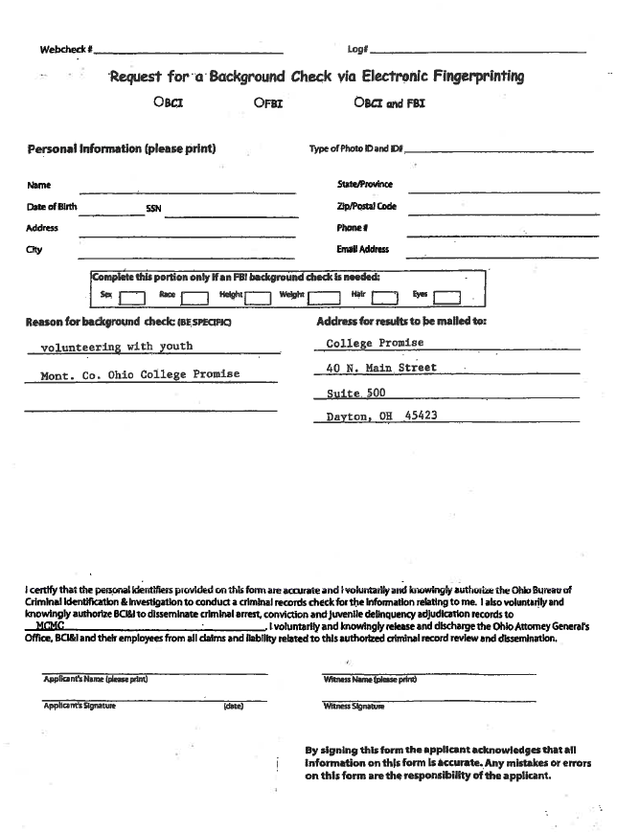
Appendix B
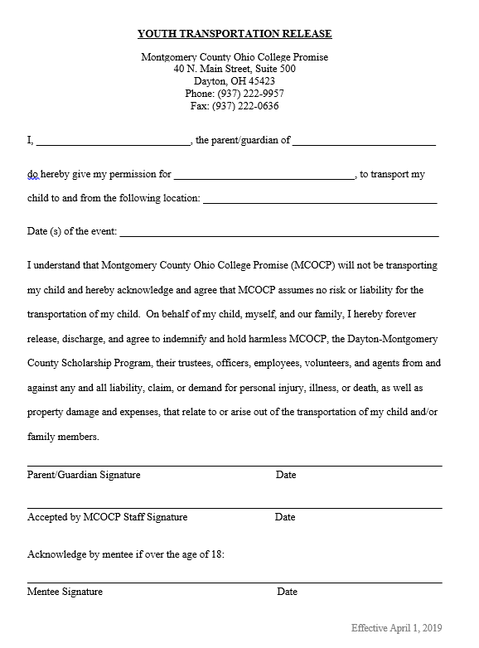
Appendix C
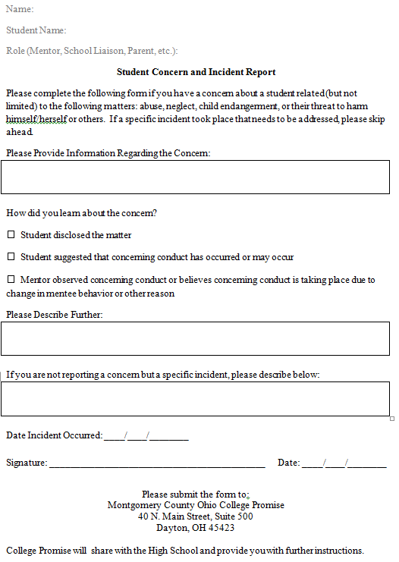

I ____________________ have received the Montgomery County Ohio College Promise Volunteer Mentor Handbook, and I agree to the policies, processes, and practices outlined in this document. I will faithfully serve in my role as a volunteer mentor in accordance with these expectations.

Signature | Date

Please detach page and return to Montgomery County Ohio College Promise.
Montgomery County Ohio College Promise
40 N. Main Street, Suite 500
Dayton, Ohio 45423

